PROJECT PLANNING PHASE
Project Planning Template – Product Backlog, Sprint Planning, Stories & Story Points
Adapted to the BlogNest project using the same planning structure as the supplied template. The original template organizes the work into epics, user stories, story points, priorities, sprints, and a sprint tracker. fileciteturn0file0L8-L15
Date | 23 September 2026
Team ID | SWTID-2026-2748
Project Name | AI BlogNest API
Maximum Marks | 5 Marks

1. Product Backlog, Sprint Schedule and Estimation
The supplied template asks for the sprint, functional requirement (epic), user-story number, user story/task, story points, priority and team members. fileciteturn0file0L9-L15
Sprint | Functional Requirement (Epic) | User Story No. | User Story / Task | Story Points | Priority | Team Members
Sprint-1 | Registration | USN-1 | As a user, I can register for BlogNest using my name, email and password. | 3 | High | Team
Sprint-1 | Authentication | USN-2 | As a user, I can log in using my registered email and password. | 3 | High | Team
Sprint-1 | Authentication | USN-3 | As a user, I can receive a successful response after registration/login. | 2 | High | Team
Sprint-2 | Blog Posts | USN-4 | As an authenticated user, I can create and publish a blog post. | 5 | High | Team
Sprint-2 | Blog Posts | USN-5 | As an authenticated user, I can view blog posts. | 3 | High | Team
TSprint-2 | Blog Posts | USN-6 | As an authenticated user, I can edit or delete my blog post. | 3 | Medium | Team
Sprint-3 | Comments | USN-7 | As a user, I can add a comment to a blog post. | 3 | Medium | Team
Sprint-3 | Search / Browse | USN-8 | As a user, I can search or browse blog content. | 3 | Medium | Team
Sprint-3 | API / Database | USN-9 | As a system, BlogNest stores and retrieves user and blog data through the API and database. | 4 | High | Team

2. BlogNest System Workflow
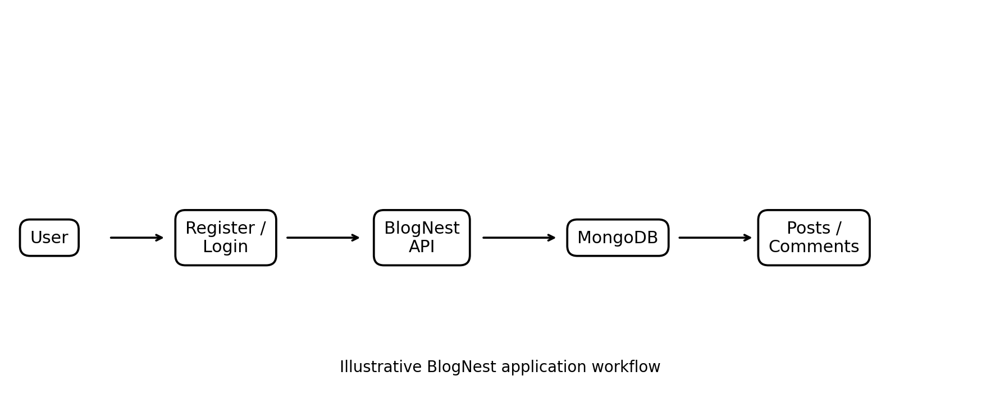
Figure 1: Illustrative BlogNest user-to-API-to-database workflow
3. Project Tracker, Velocity & Burndown Chart
The supplied template uses sprint total story points, duration, start date, planned end date, completed story points and actual release date as the sprint-tracking fields. fileciteturn0file0L40-L53
Sprint | Total Story Points | Duration | Sprint Start Date | Sprint End Date (Planned) | Story Points Completed | Sprint Release Date (Actual)
Sprint-1 | 8 | 6 Days | 24 Sep 2026 | 29 Sep 2026 | — | —
Sprint-2 | 11 | 6 Days | 30 Sep 2026 | 05 Oct 2026 | — | —
Sprint-3 | 10 | 6 Days | 06 Oct 2026 | 11 Oct 2026 | — | —

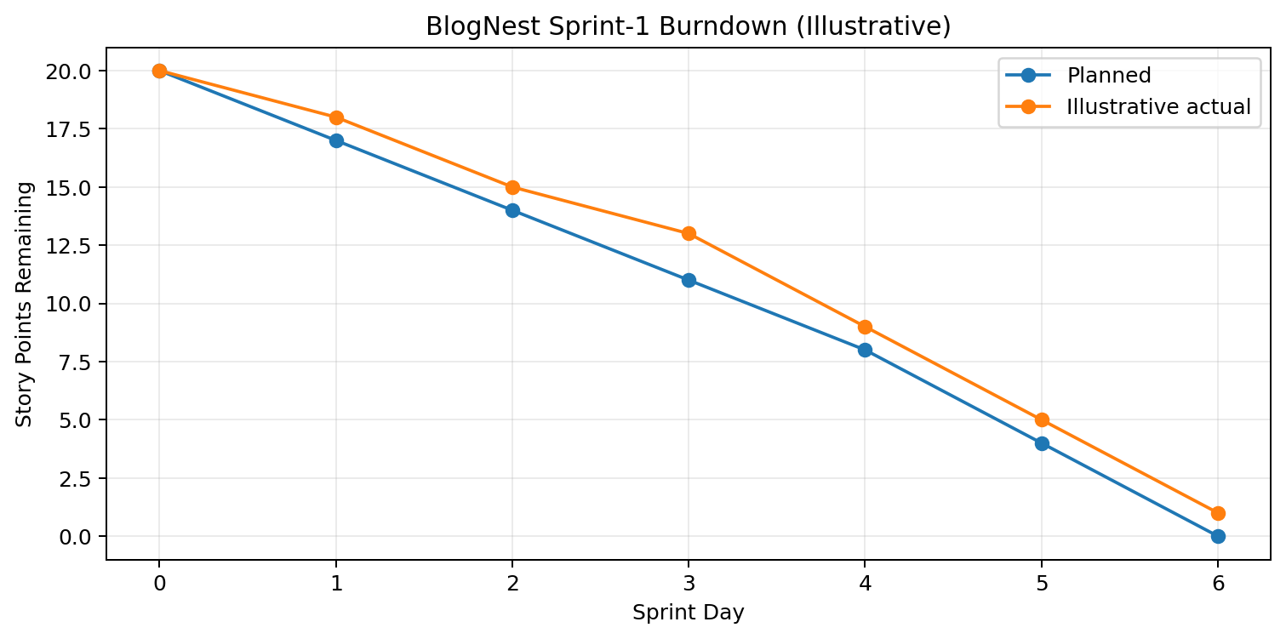
Figure 2: Illustrative Sprint-1 burndown chart for BlogNest
4. Velocity
The supplied template explains velocity as the team's completed story points over a sprint and illustrates converting sprint velocity into an average per-iteration-unit value. fileciteturn0file0L55-L57
For BlogNest, velocity can be recorded after each completed sprint. Example: if 20 story points are completed in a 6-day sprint, average daily velocity = 20 ÷ 6 = 3.33 story points/day.
5. Burndown Chart
A burndown chart represents work remaining against time and is commonly used in Agile/Scrum projects. The supplied template describes it as a graphical representation of work left to do versus time. fileciteturn0file0L58-L60
The chart above is illustrative; replace the actual-completed values with the team's real sprint data when the sprint is executed.
6. Summary
BlogNest is planned through three sprints covering registration and authentication, blog-post management, comments/search, and API/database operations. The backlog converts these functions into user stories with story points and priorities, while the sprint tracker and burndown chart provide a simple way to monitor progress.
Reference
https://www.atlassian.com/agile/project-management
https://www.atlassian.com/agile/tutorials/how-to-do-scrum-with-jira-software
https://www.atlassian.com/agile/tutorials/epics
https://www.atlassian.com/agile/tutorials/sprints
https://www.atlassian.com/agile/project-management/estimation
https://www.atlassian.com/agile/tutorials/burndown-charts

